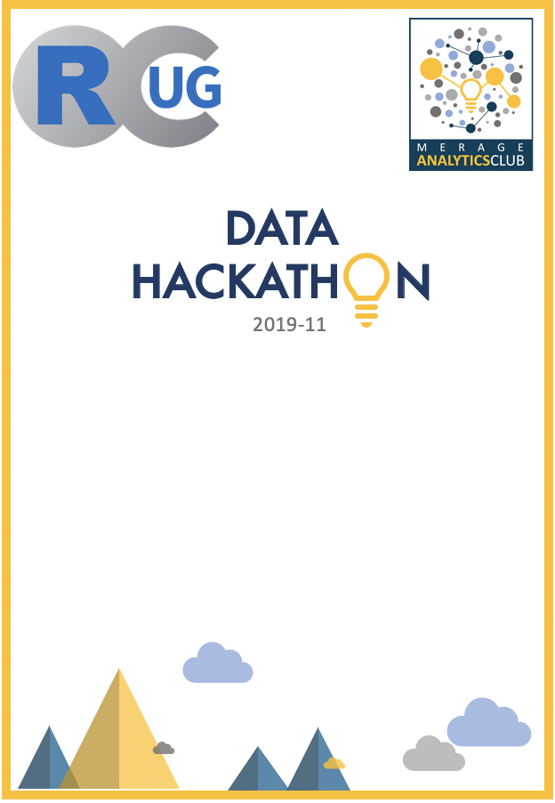

**ADWAIT TORO**

Participant

**AI LING TING**

Participant

**ALEXANDER OINEZA**

Participant

**ANUJA DIXIT**

Participant

**ARLO RANDALL**

Volunteer

**ASHISH GUPTA**

Participant

**BASIL LATIF**

Participant

**CHAVI SINGAL**

Participant



**GARY VARTANIAN**

Participant

**HAN YIN**

Participant

**HONG XIAO**

Participant

**HUHAO ZHU**

Participant

**HUNG PHAN**

Participant

**INDU MANIMARAN**

Participant

**JT SARMENTO**

Participant/Organizer

**JENNIFER SIWU**

Participant/Organizer



**JOHN PEACH**

Organizer

**JOHN SHOJAEI**

Participant

**JOSEPH LOPEZ**

Participant

**KASSIUS SANTOS**

Participant

**KENT JITPATIMA**

Participant

**KEREN XU**

Participant

**KEVIN PRESTON**

Participant

**KEVIN STACHELEK**

Participant



**KUANG LI**

Participant

**LUYAO LI**

Participant

**MAHDI HOSSEINI**

Participant

**MANOJ PYLA**

Participant

**MOHAMED ABDELHAMID**

Volunteer/Judge

**NICK HEFNER**

Participant

**NIYAZEE MUTHAZZIR**

Participant

**PRIYA SHIVAANI**

Participant



**RYAN BENZ**

Organizer

**RYAN LUU**

Participant/Organizer

**SADAF MEHDI ZADEH**

Participant

**SARAH LIU**

Participant/Organizer

**SEPEHR EFTEKHARIAN**

Participant

**SHUOCHEN XU**

Participant

**SIKAI WANG**

Participant

**SONAL MENDIRATTA**

Participant/Organizer



**STELLA YANG**

Participant

**SUNNY ZHOU**

Participant

**SUSHRUT SHENDRE**

Participant

**TAKAKO SUZUKI**

Participant/Organizer

**VARUN SHARMA**

Participant

**VISHNU MADAN** Participant

**VIVIAN KANG**

Participant

**XI CHEN**

Participant



**YONGYUAN WAN**

Participant

**YORK FANG**

Participant

**YU ZHANG**

Participant

**YUAN LIU**

Participant

**ZHI YANG**

Volunteer

**HOWARD KIM**

Participant

**SAMEER RATHI**

Volunteer/Organizer

  


**JEREMY CHANG**

Participant

**JOSEPH RIESTRA**

Participant

**ANAS MUGHAL**

Participant

**TINGYU YANG**

Participant

**TIKIRI KARUNASUNDERA**

Participant

**PATRICK LEE**

Participant

**DINH TON**

Participant

**TEMUULEN ENEBISH**

Participant

**CAREY HUH**

Participant